

Practices for Secure Software Report

Table of Contents
Document Revision History 3
Client 3
Instructions 3
Developer 4
1. Algorithm Cipher 4
2. Certificate Generation 4
3. Deploy Cipher 4
4. Secure Communications 4
5. Secondary Testing 4
6. Functional Testing 4
7. Summary 4
8. Industry Standard Best Practices 4

Document Revision History

Version | Date | Author | Comments
1.0 | 10/18/2026 | de Plata, Jeremy | Initial Report

Client



Instructions

Submit this completed practices for secure software report. Replace the bracketed text with the relevant information. You must document your process for writing secure communications and refactoring code that complies with software security testing protocols.

- Respond to the steps outlined below and include your findings.
- Respond using your own words. You may also choose to include images or supporting materials. If you include them, make certain to insert them in all the relevant locations in the document.
- Refer to the Project Two Guidelines and Rubric for more detailed instructions about each section of the template.

Developer
de Plata, Jeremy

Algorithm Cipher

For the Artemis Financial application, I generated a self-signed certificate using RSA with a 2048-bit key. RSA is an asymmetric algorithm that uses a public and private key. The public key can be distributed to anyone while the private key must be kept secure. This will allow the server to prove its identity to a client connecting over HTTPS.
SHA-256 generates a checksum based on a piece of information. You can use this to determine if your information has been tampered with by comparing the checksum to the original. There is no practical way to reverse the hash to recover the original information. Which is why I decided to use SHA-256. HTTPS also uses symmetric encryption to protect the information being transferred between the client and server after a secure connection is established.

Certificate Generation
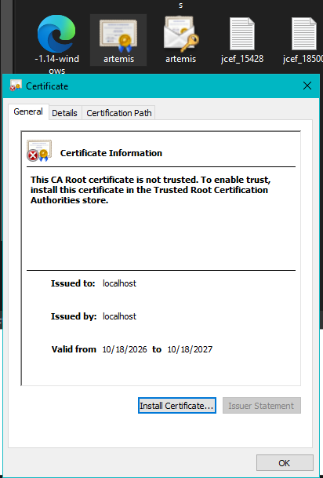

Deploy Cipher


Secure Communications
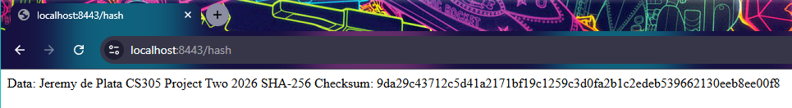

Secondary Testing
Insert screenshots below of the refactored code executed without errors and the dependency-check report.

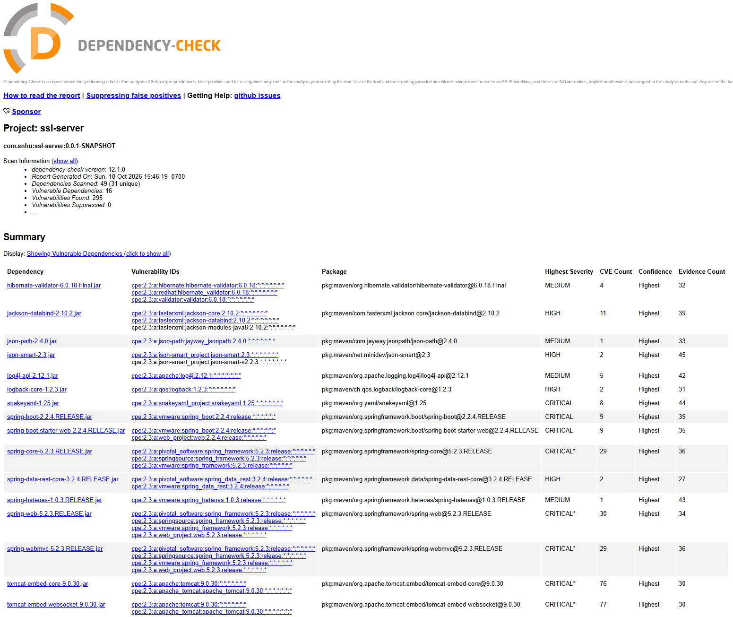
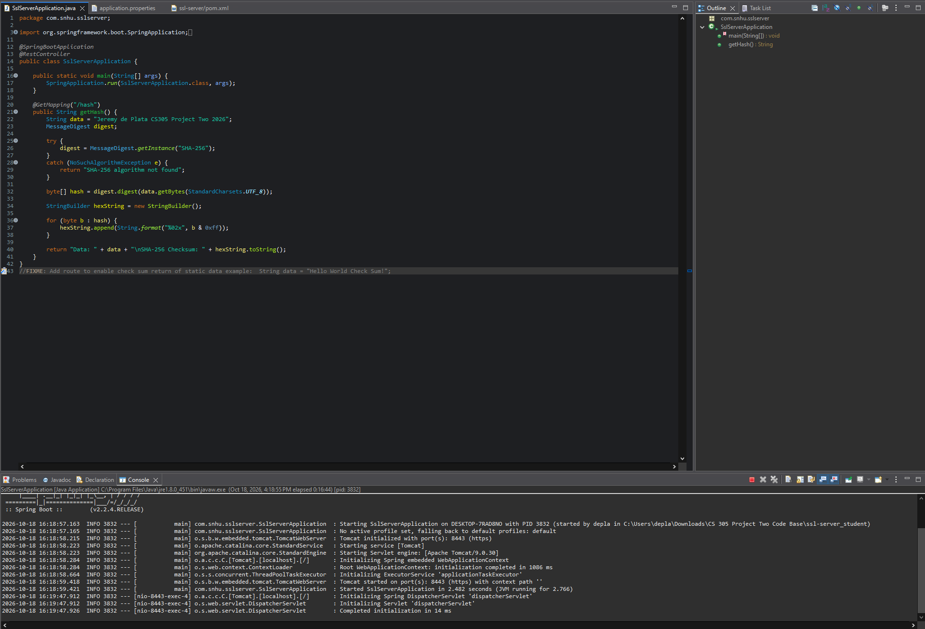

Functional Testing
Insert a screenshot below of the refactored code executed without errors.

Summary

I applied SHA-256 hashing to the Artemis Financial application to create a hash/checksum. Then changed my application to use HTTPS instead of HTTP. I generated a certificate using RSA to help secure communication between the client and server. Once complete, I tested my application and it was up and running.
I ran the OWASP dependency-check scan to check for vulnerabilities. There were 295 vulnerabilities that were found. There were 16 dependencies that were vulnerable. My application was able to run with no issues, but these vulnerabilities would have to be addressed to better protect the application.

Industry Standard Best Practices

By ensuring your private keys are safe you can help prevent people from impersonating your servers. You want to make sure that only people who are authorized to access your private key can get to it. Never store your password directly in your application's code as well.
Always test your applications for vulnerabilities. I used OWASP dependency-check on my application to see if there were any vulnerabilities with the dependencies I was using. You want to keep up to date on your dependencies and see if there are any changes that you should apply. Test your application after changing anything to ensure nothing broke.

